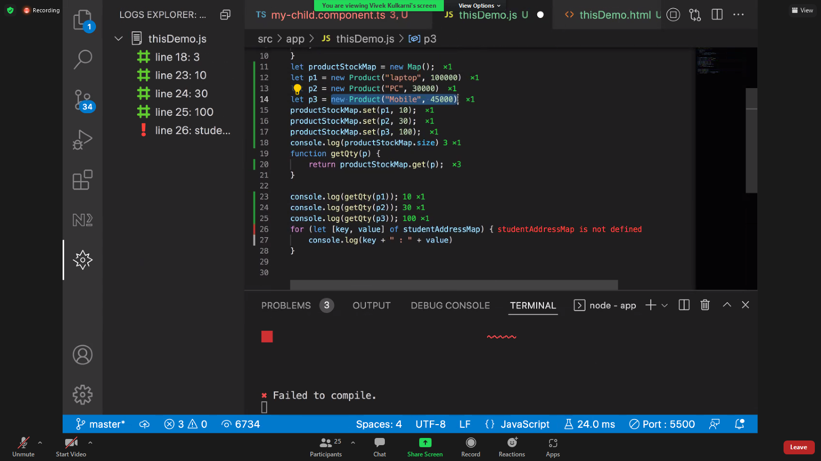

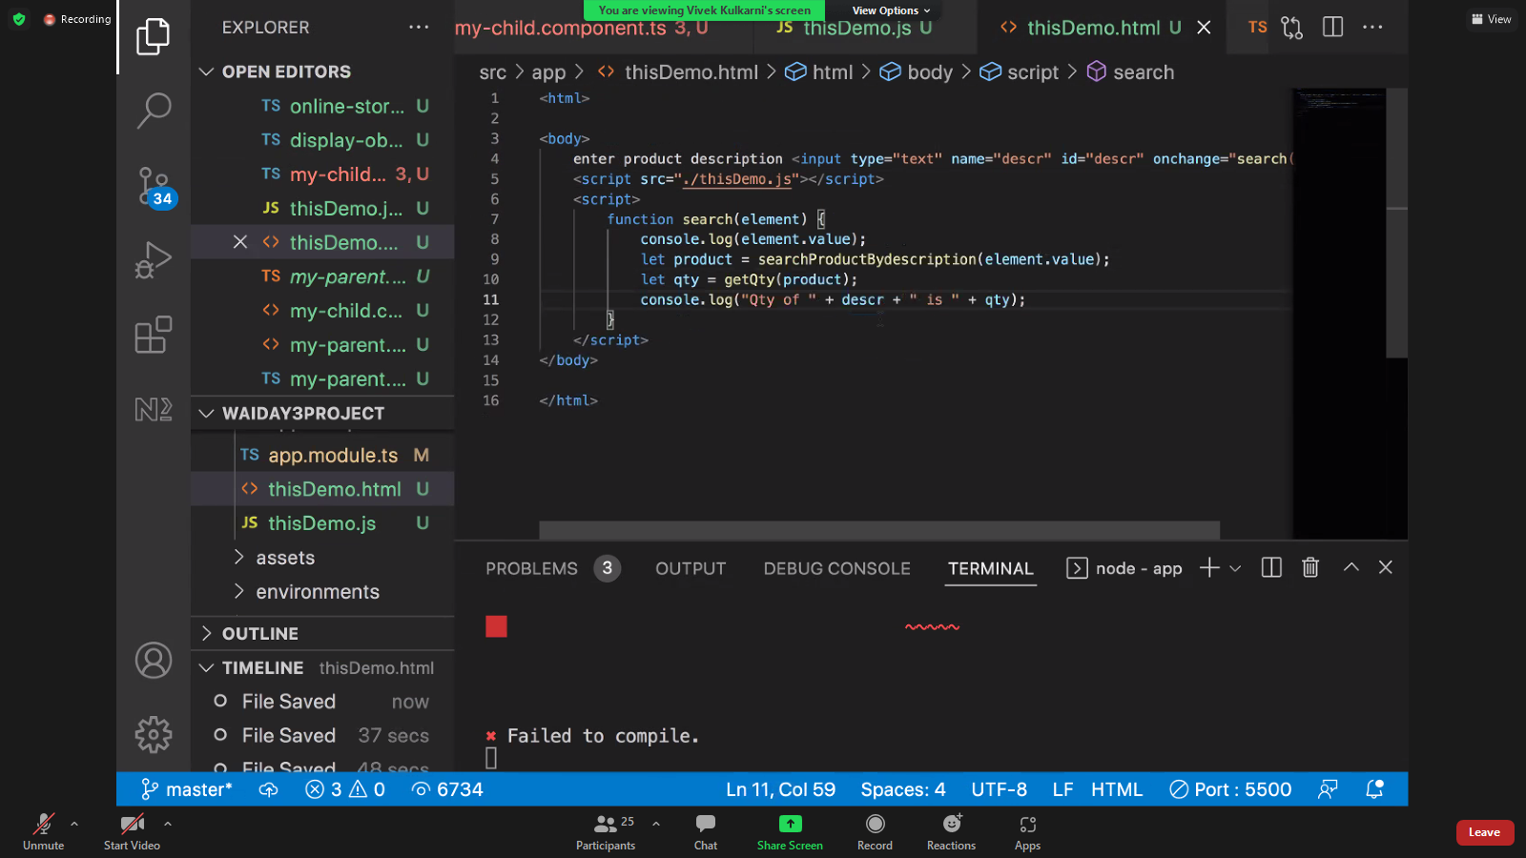

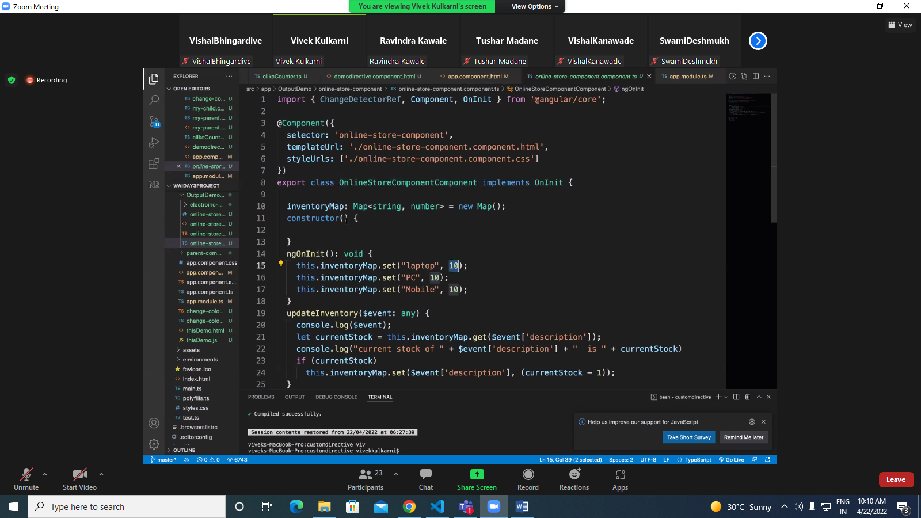

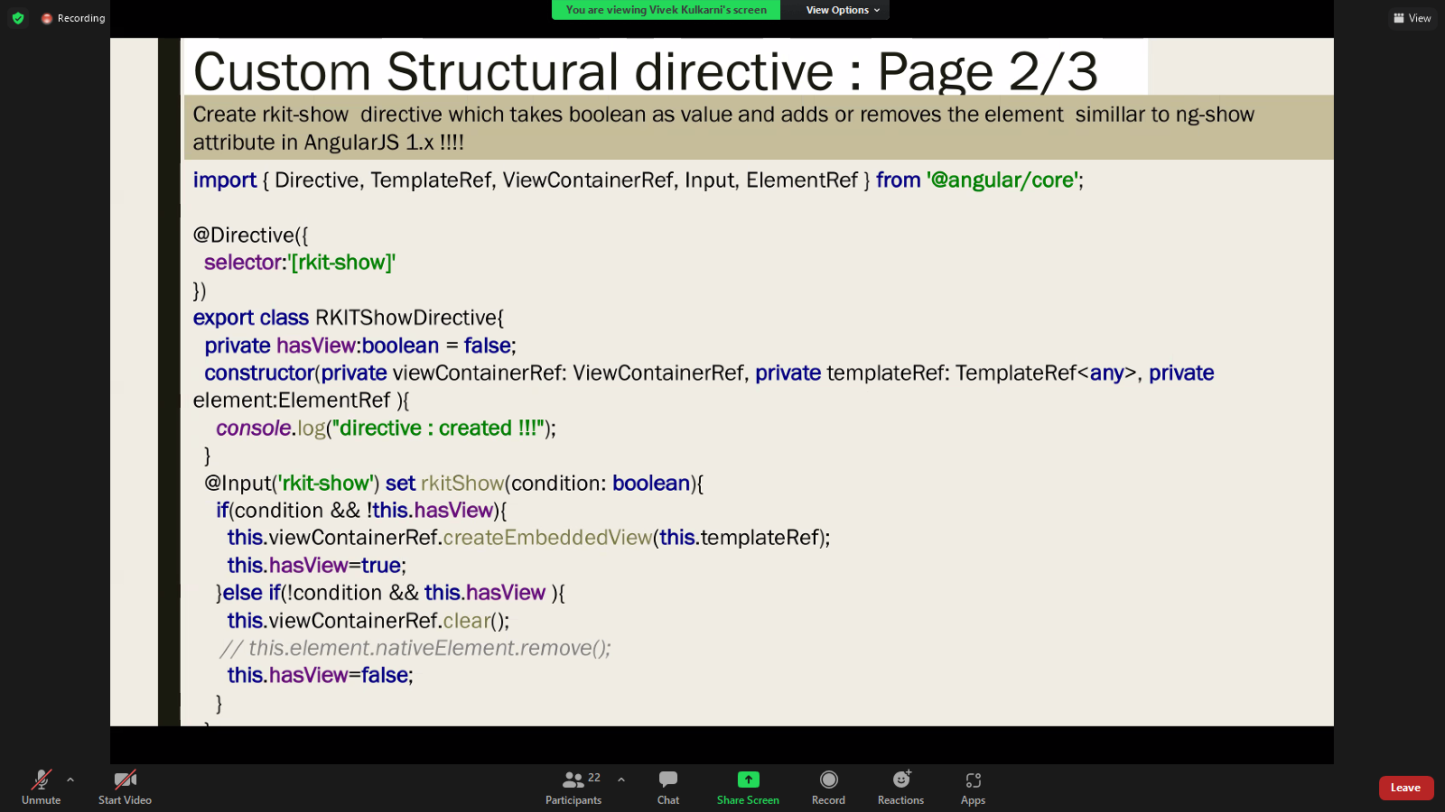

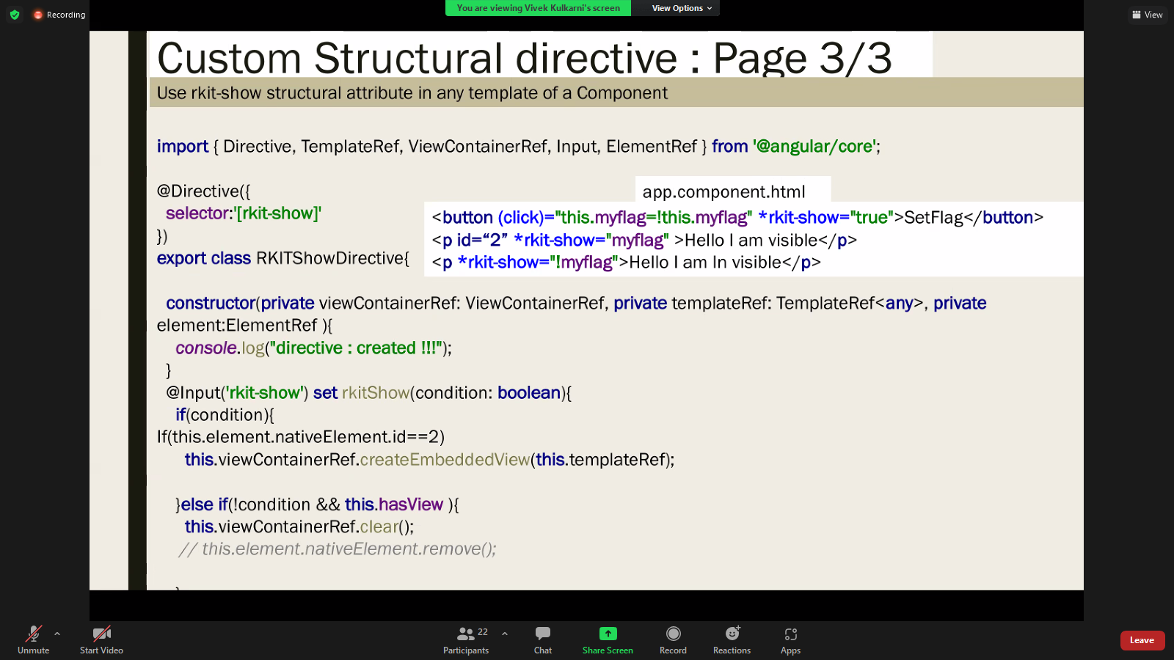

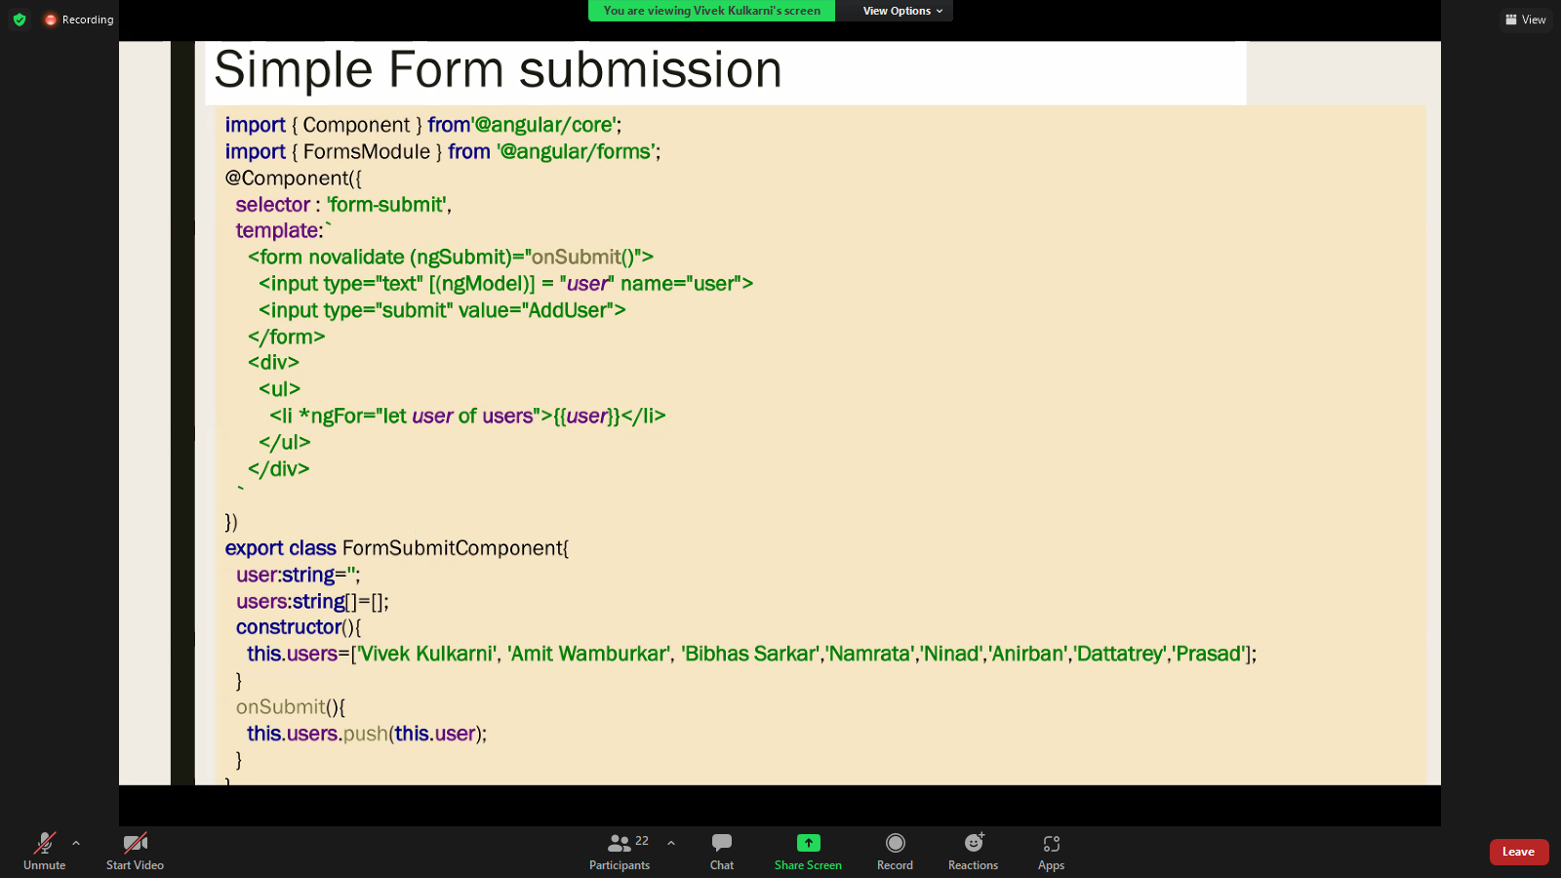

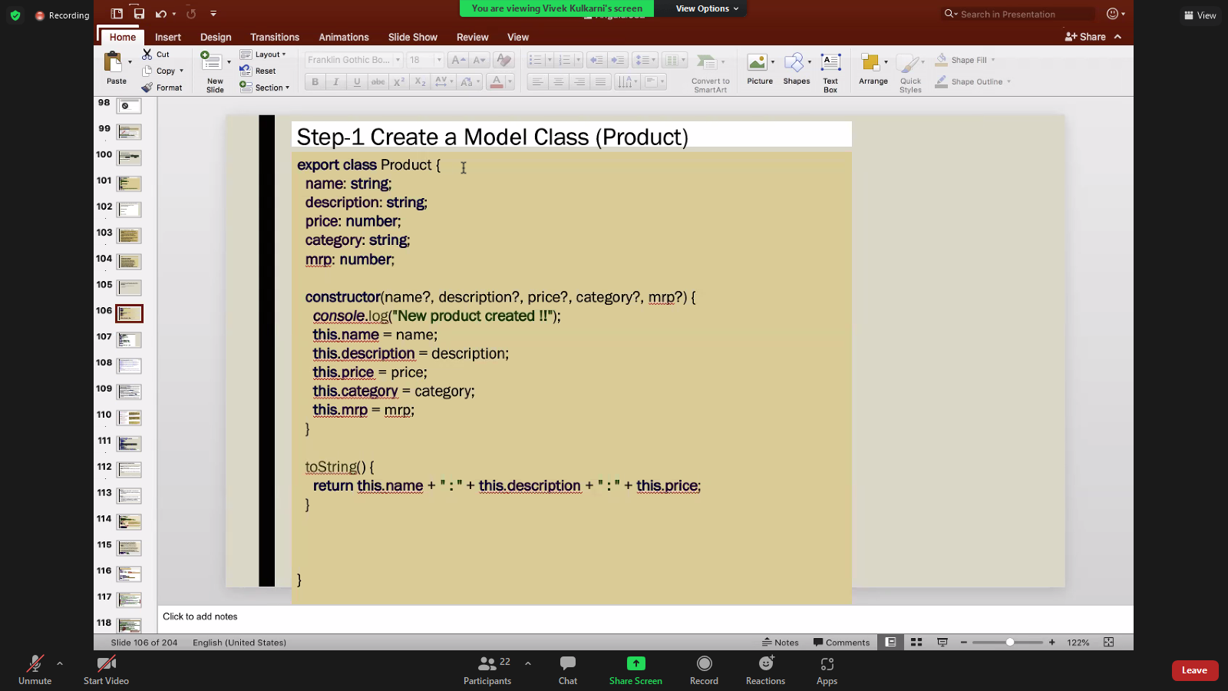

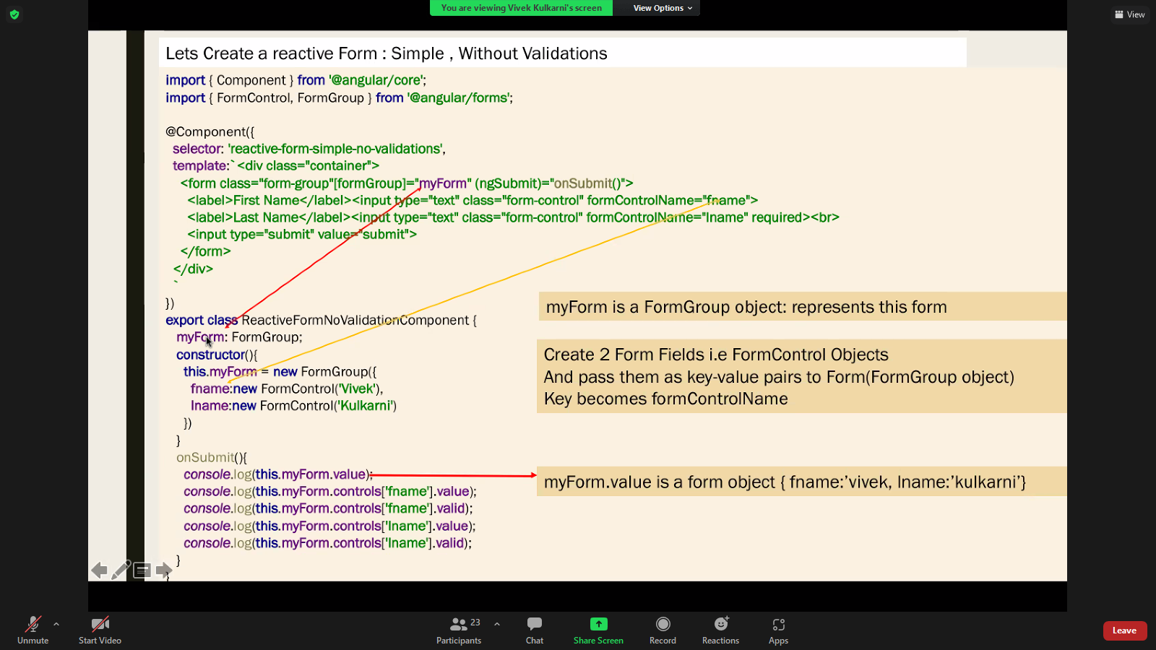

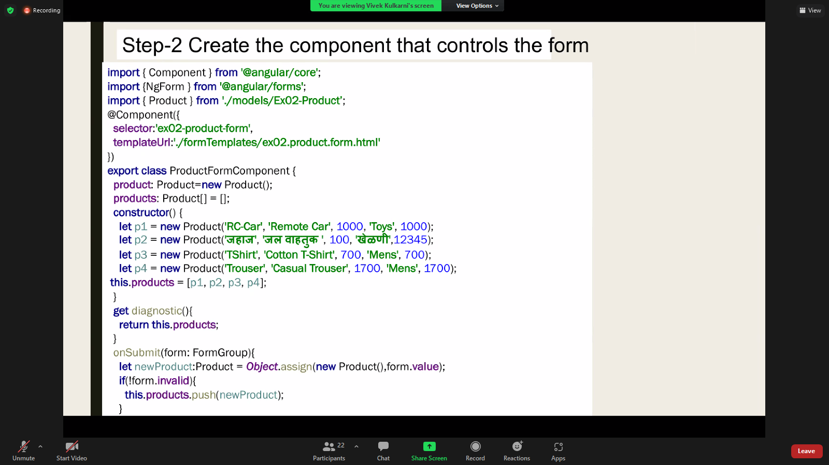

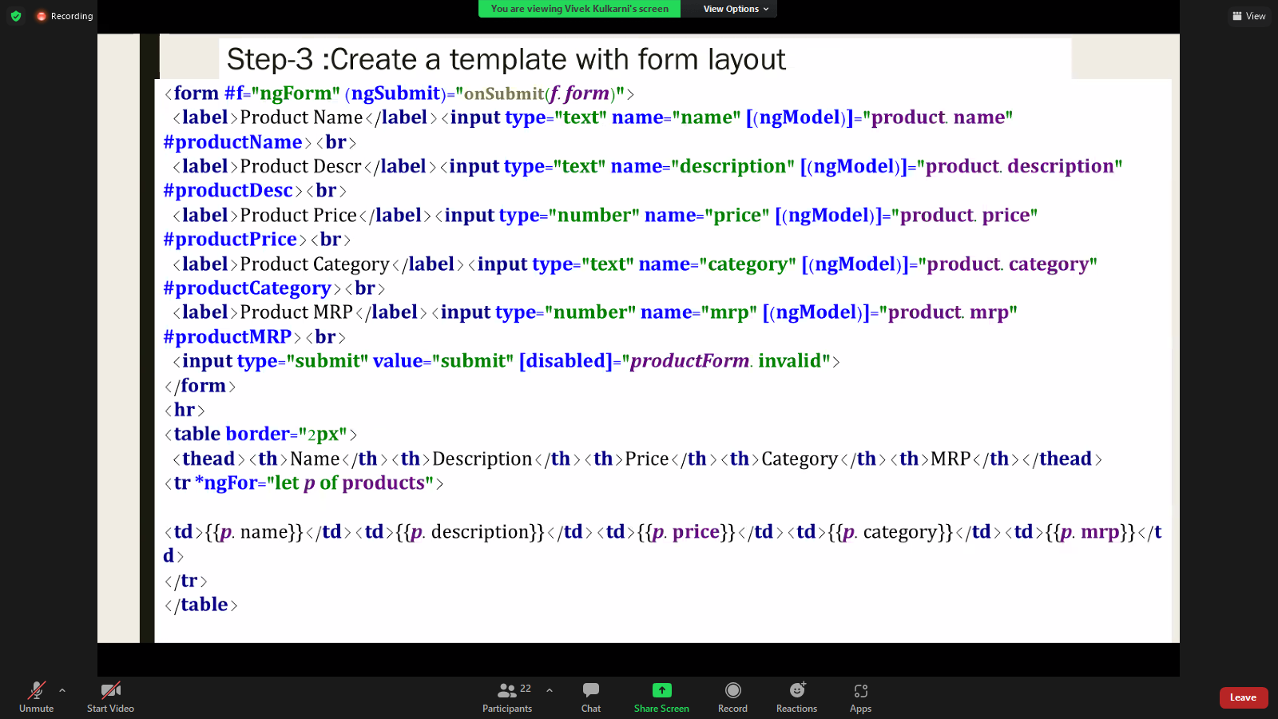

/\* TODO#1 Create a directive with 2 attribute selectors my-bgColor and text-color \*/@Directive({})export class HighLightWIthInlineProperty implements AfterViewInit{ /\* TODO #2 make hightLightCOlor property as an alias of my-bgColor i.e. selector itself \*/ highLightColor:string; /\* TODO #3 make fontColor property as an alias of text-color i.e. selector itself \*/ fontColor:string; private myElement:any; constructor(element:ElementRef){ this.myElement=element.nativeElement; } ngAfterViewInit(){ /\* TODO # 4 set element'sbackGroundColor to highLightColor\*/ /\* TODO # 5 set elements' text color to fontcolor\*/ this.myElement.style.color=this.fontColor; } /\* TODO # 6 provide Listener function which should be called on mouse click

When user clicks, colour should become red, when user clicks again

it should become blue.(so should swap colors).

\*/

}